**Into the Badlands Season 4: Release Date and other details!** 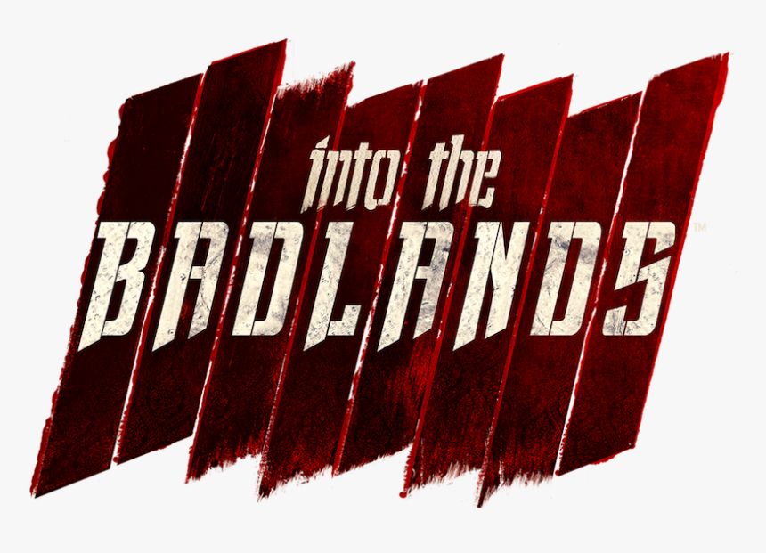

***Into the Badlands***, an American television series of action, adventure, and drama genre created by Alfred Gough and Miles Millar that streamed on November 15, 2015, on AMC. The television series is partly grounded on the excellent Chinese tale named "*Journey to the West*".

**Into the Badlands Season 4: Release Date**

**AMC** announced the release of six episodes each 1 hour long of the thriller drama to be released in the second half of 2015 produced by AMC Studios. Season 1 was broadcasted from November 15, 2015, to December 20, 2015. Then AMC renewed the series for Season 2 comprising of 10 episodes which streamed from March 19, 2017, to May 21, 2017. Then again on April 25, 2017, AMC announced the renewal of the series Season 3 which streamed from April 22, 2018, to May 6, 2019. On February 9, 2019, AMC announced *the cancellation of the series* after 3 seasons with mixed reviews not coming up with the expectations of the creators of the show. So, ***Season 4*** is highly likely not to be released at any time unless AMC decides to revive the series for another season.

**Into the Badlands Season 4: Expected Cast and Plot**

It's a sci-fi martial arts series. It revolves in a post-apocalyptic world, nearly 500 years ahead in the future, when war has the civilizations ruined. Despite ruining the civilization few technologies survived such as electricity and ground vehicles. But people left the guns used previously and they came to use melee weaponry and crossbows for defense and other purposes.

In ***Badland***, a territory located between the Rocky Mountains and Mississippi River, a society of medieval people lives there trying to fill up the vacuum created by the war. The land and the monopolies over few items like opium and fuel are controlled by the Barons. They used to trade amongst themselves maintaining peace and harmony. The ***Barons*** seem to be powerful, each of them is accompanied by a huge workforce of slaves called cogs, besides an escort class called dolls. They used to maintain their supremacy among the people by managing an army of young men and women called clippers, who're greatly upskilled and faithful soldiers, they're restricted from marrying and having children to avoid the division of their loyalties. Each of these clippers is captained by a regent.

There're many groups in the Badland, who exists outside the hierarchy of the barons, nomads being the most common one. Nomads are mostly unruly robbers who used to rob from the trade groups between the baronies but some of them live in well-planned clans too. There's River King who controls the water trade in the Badland seeking help from his men and they don't meddle in the Baron's fight for supremacy. Other communities and societies are also said to exist but only a few of them are known, mostly they're either less stable politically or they seem to be more like Badlands.

In Season 3 in the last, we saw the widow and Sunny retrieves their might and strength. Tilda gets significantly bruised while both Pilgrim and MK succumbed and died. Cressida runs off on a boat before Moon could do her in, and we came to know of a huge ultimatum that's about to come to the ***Badland***.

Season 1 unveiled the cynical villain, ***Quinn***, while Season 2 made him scarier. Season 3 introduced Pilgrim to us opening the storyline more and more than we saw in the previous seasons. And now ***Season 4*** is most likely to introduce many new characters to the series. Two of our warriors will be regaining their gift on even knowing that it could destroy their goal and can pose a threat to their dearest ones. Additionally, other twists and turns can be introduced as per the writers' direction in which he would like to take up the story, he may introduce guns into the story or can continue with the swords and other old weapons. Now let's talk about a few characters who're likely to reprise their roles if ***Season 4*** will be announced someday. 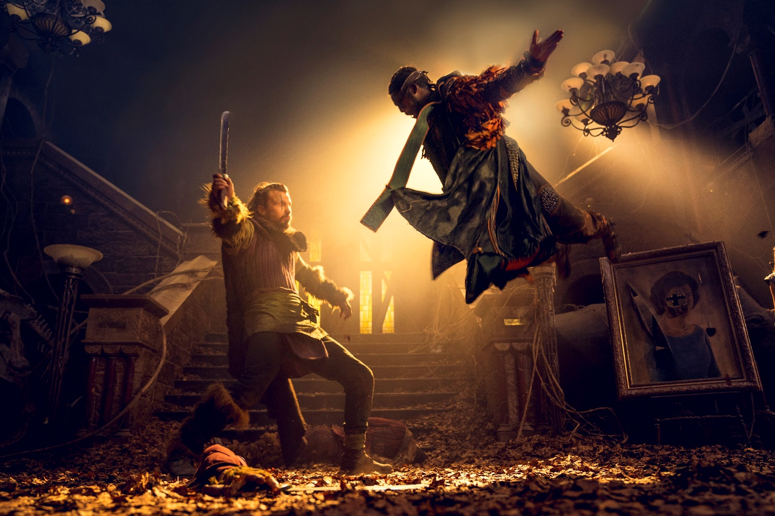

Daniel Wu being **Sunny**- He's a regent, (head clipper) to the Badland's most mighty baron named Quinn. He's very faithful to Quinn and he's very experienced and adept in many weapons. He's considered to be one of the lethal clippers in the whole Badland.

Orla Brady being **Lydia**- She's Quinn's first wife, who's his most faithful follower. She produces opium poppies. She collaborates with The Widow and becomes her Viceroy and takes charge of Quinn's residence.

Sarah Bolger being **Jade**- She's to be Quinn's second wife who later on marries her step-son, Ryder, after Quinn's believed death. She's a manipulative person.

Emily Beecham being Minerva aka The Widow- She's the Badland's newest baron. She's a well-skilled martial artist. She owns the territory which produces crude oil.

Oliver Stark being **Ryder**- He's the heir and only son of Quinn and Lydia. He marries his step-mother Jade and takes over Quinns' charges as baron after his assumed death.

Madeleine Mantock being Veil- She's a doctor by profession who's in a secret relationship with Sunny.

Ally Ioannides being Tilda- She's Widow's adopted daughter who's well-tutored in martial arts like The Widow. She robs precious supplies across the Badlands under "Iron Rabbit".

Marton Csokas being ***Quinn***- He's the Badland's most prominent baron and a former clipper. He owns the territory which produces opium poppy.

And many others.

**Into the Badlands Season 4: Trailer**

***Into the Badlands Season 4 trailer*** has not been released but you can enjoy ***Into the Badlands Season*** 3 ***trailer***😊

https://www.youtube.com/watch?v=C-1CHFK-aRM